Erin Mandell

October 5, 2019, 2019

Pymaceuticals Report

The Pymaceuticals exercise required us to plot and analyze the results of a 45 day trial of three drugs and a placebo administered to 25 mice with cancer. According to the data we’ve been given, one drug stands out as being far more effective than either the other 2 or the control (placebo).

Our first graph shows that Capomulin shrinks tumors over the study time period, while the tumors grow for the other mice.

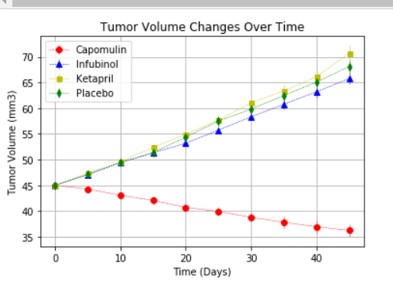

All mice experienced metastatic spread during the study, but the spread was slowest for those given Capomulin.

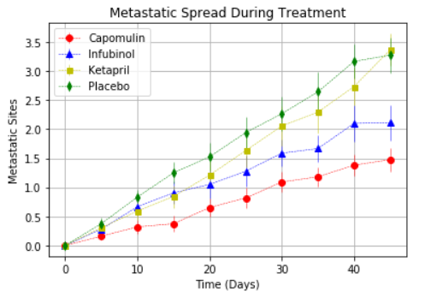

While subject mice being administered each of the drugs did die, the fewest died while on Capomulin, which is another way of saying that the research demonstrates that on average, this drug extends life to a significant degree.

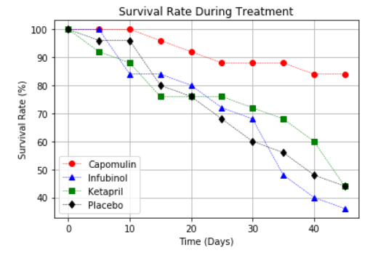

This final chart is giving us a another look at the tumor growth/shrinkage during the study period. The mice receiving Capomulin saw tumor reduction by nearly 20%, while those receiving the other two drugs and the placebo saw roughly a 50% growth rate.

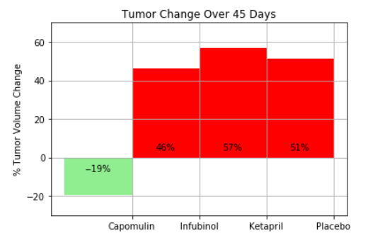

In conclusion – the study data indicates that Capomulin looks to be a promising drug for treating cancer: it reduces tumor size, slows metastatic spread, and extends life. The other two drugs do not seem to show results that are significantly different than the placebo, however. They did slow metastatic spread somewhat as compared to the placebo, but did not improve survival at the 45 day mark, and didn’t alter the tumor growth results very much.